Understanding Wireless Sensing: A Deep Dive into Channel State Information (CSI)

Prepared by:
Dylan Dhawan
University of Maryland

Date: December 10, 2025

Table of Contents

Understanding Wireless Sensing: A Deep Dive into Channel State Information (CSI) 1
1. Introduction: The Invisible Network 3
2. The Theory: Physics of the Wireless Channel 3
2.1 Multipath Propagation: 3
2.2 Constructive and Destructive Interference 4
2.3 The Limitations of RSSI 5
2.4 Enter CSI: The High-Definition View 5
3. The Frequency Domain and OFDM 5
3.1 How OFDM Works: 6
The 802.11n Frame Structure (20 MHz) 6
3.2 Extracting CSI: The Mathematical Model 6
3.3 From ESP32 to Python: Processing the Data 7
4. Visualizing the Invisible: Analyzing the Heatmaps 8
1. The "Quiet" Zones (Sitting Still) 11
2. The "Event" (The Scratch) 12
4.2 Standing in Front of COM11 (Triangulation Setup) 13
5. Real-World Applications 15
5.1 Elderly Care: Privacy Preserving Fall Detection 15
5.2 Security: The "Invisible" Burglar Alarm 15
5.3 Vital Signs Monitoring: Breathing and Heart Rate 15
6. Conclusion 16
Works cited 17

1. Introduction: The Invisible Network
This report expands on this technology, focusing specifically on Channel State Information (CSI). Unlike the traditional Received Signal Strength Indicator (RSSI), which offers a coarse and unstable measure of signal power, CSI provides a high-resolution, spectral view of the wireless channel. It allows us to turn standard Wi-Fi devices, like the ESP32 microcontrollers used in the accompanying experiments, into powerful sensing radars.
The following sections will serve as a comprehensive guide to understanding CSI. And importantly, we will test this theory using real world experimental data, analyzing heatmaps generated from a single-receiver motion detection setup and a dual-receiver.

2. The Theory: Physics of the Wireless Channel
When a transmitter (Tx) sends a packet to a receiver (Rx), the signal does not travel through a vacuum, it traverses a complex environment filled with noise. The signal that arrives at the receiver is not a single, clean copy of the transmitted signal; it is a superposition of many different wavefronts. This is known as Multipath Propagation.¹

2.1 Multipath Propagation:
In an indoor environment, such as the conference room where the ESP32 experiments were conducted, the electromagnetic waves emitted by the transmitter radiate outwards.. As these waves encounter all the different objects and undergo several physical interactions:
- Reflection: When a wave hits a large smooth surface (like a wall or floor) with dimensions larger than the signal's wavelength (about 12.0 - 12.5 cm for 2.4 GHz Wi-Fi), it reflects, creating a new path for the signal to travel.
- Diffraction: When a wave encounters a sharp edge (like the corner of a desk or a doorway), it bends around the obstacle. This allows the signal to reach areas that are shadowed from the direct line of sight.
- Scattering: When the wave hits an object with dimensions smaller than or comparable to the wavelength (like a coffee mug or the surface of a human body), it is scattered in many directions.¹
The receiver antenna collects all these reflected, diffracted, and scattered waves. However, because each path has a different physical length, the waves arrive at different times. This is called Delay Spread.
Let us define the transmitted signal as x(t). The received signal y(t) is the sum of N multipath components:

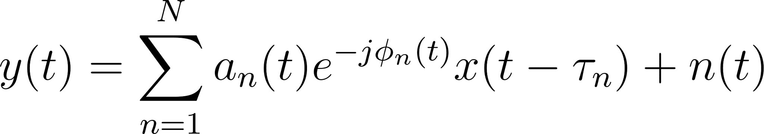

Where:
-  is the amplitude attenuation of the -th path.
- 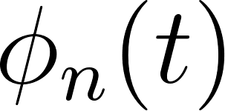 is the phase shift of the -th path.
-  is the time delay (time-of-flight) of the -th path.
- 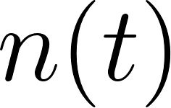 is the additive noise.
It is this specific combination of amplitudes, phases, and delays that acts as a fingerprint of the room's shape at that exact moment. If the room is static, the fingerprint remains constant. If a person moves, they change the reflection paths (), thus, changing the fingerprint. Wi-Fi sensing is essentially detecting and interpreting these changes.¹

2.2 Constructive and Destructive Interference
The interaction of these multipath components at the receiver antenna is set by the principle of superposition.
- Constructive Interference: If two waves arrive "in phase,” they sum together, resulting in a stronger signal.
- Destructive Interference: If two waves arrive "out of phase,” they cancel each other out, resulting in a weaker signal.
Whether interference is constructive or destructive depends on the frequency/wavelength of the signal. For example, a path difference of 1 meter might be exactly one full wavelength for frequency  (constructive), but  wavelengths for frequency 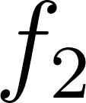 (destructive).
This results in Frequency Selective Fading which means in a wideband channel, some frequencies will be amplified by the room's shape, while others will be attenuated.² This is the physical origin of the "vertical stripes" we will analyze in the heatmaps later. The room acts as a filter, shaping the spectrum of the signal.

2.3 The Limitations of RSSI
For a very long time, the standard exposed by Wi-Fi chips was the Received Signal Strength Indicator (RSSI). RSSI is a scalar value which represents the total power of the received signal, averaged over the entire bandwidth and more often over the duration of the packet.¹
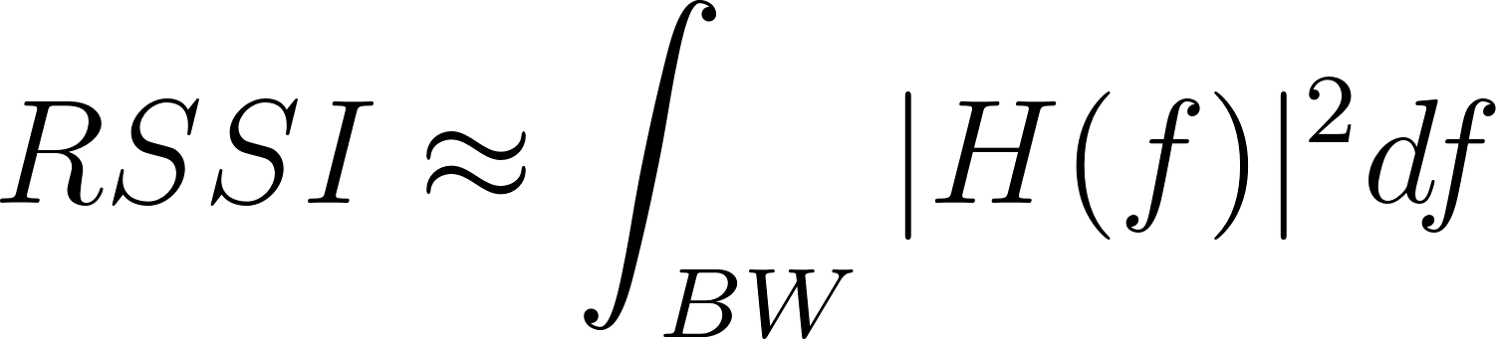

While RSSI is useful for determining if a device is within range, it is very limited in terms of sensing:
- Coarse Granularity: It combines and dwindles down the frequency-dependent multipath information into just a single number. You lose the details of which frequencies are fading.
- Instability: Because it is a sum, a constructive change at one frequency can be cancelled out by a destructive change at another. This makes RSSI noisy and unreliable for detecting subtle movements.⁵
- Lack of Phase: RSSI contains only magnitude information. It discards the phase data, which is highly sensitive to motion (Doppler shifts) and distance changes.⁶

2.4 Enter CSI: The High-Definition View
CSI solves these limitations by providing the channel properties at greater detail. Instead of a single power value, CSI provides a matrix of numbers representing the amplitude and phase response for each individual subcarrier in the Wi-Fi signal.⁷
The detailed spectral breakdown of CSI data allows us to tell the difference between static multipath and dynamic multipath, and even to leverage the spatial diversity of different subcarriers to improve detection accuracy.
In the experiments with the ESP32, we are extracting this raw physical layer data.

3. The Frequency Domain and OFDM
To process and interpret the data from the ESP32, we need to understand how modern Wi-Fi transmits data. The technology being used today is called Orthogonal Frequency-Division Multiplexing (OFDM).

3.1 How OFDM Works:
In a traditional single carrier system, data is transmitted sequentially on one frequency. If that frequency goes through a deep fade due to multipath propagation then that signal is lost. OFDM overcomes this issue by splitting the high speed data stream into many lower speed data streams and transmitting them simultaneously over multiple, closely spaced frequencies which we call subcarriers.⁷
These subcarriers are "orthogonal," which means they are mathematically independent. The peak of one subcarrier corresponds to the zero crossing of its neighbors, preventing Inter-Carrier Interference.
In the 20 MHz bandwidth mode used by the ESP32 (802.11n standard), the channel is divided into 64 subcarrier indices, typically indexed from -32 to +31:
- Data Subcarriers (52): Used to carry the actual information.
- Pilot Subcarriers (4): Located at indices -21, -7, 7, and 21. These carry a known signal pattern and are used by the receiver to correct for frequency offsets and phase noise.
- Null Subcarriers (8): Located at the edges and at the center (index 0) to prevent interference with adjacent channels and internal electronics.⁷

3.2 Extracting CSI: The Mathematical Model
When the ESP32 receives a packet, it must "equalize" the channel. It compares the received signal on each subcarrier with the known transmitted signal to estimate the distortion caused by the air. This estimate is the CSI.
Mathematically, for a specific subcarrier  and time , the received signal  is:


Where:
-  is the transmitted symbol.
-  is the Channel State Information (the distortion).
-  is the noise.
The Wi-Fi chip estimates  by dividing the received signal by the known transmitted symbol:

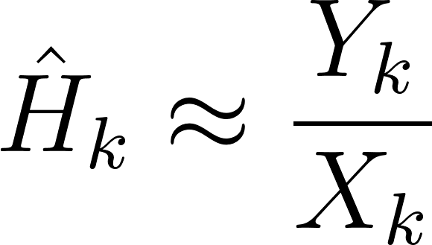
The result, , is a complex number. It is not just a magnitude but rather, it has a real part () and an imaginary part ().


Or in polar form:
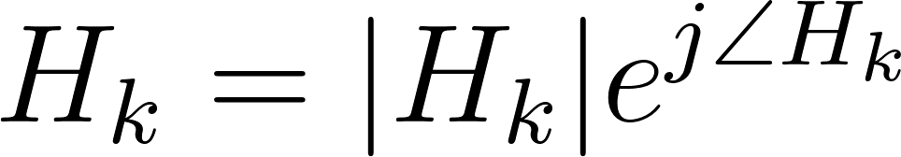

- Amplitude (): Represents the attenuation or signal strength of that specific subcarrier.
- Phase (): Represents the phase shift of that subcarrier.

3.3 From ESP32 to Python: Processing the Data
In our experiments, the ESP32 captures this  matrix for every received packet and sends it to the processor. The Python script is simply translating these raw bytes into physical quantities.

4. Visualizing the Invisible: Analyzing the Heatmaps
We now turn to the evidence gathered from our experiments. The CSI heatmaps captured are not abstract charts; they are direct visualizations of the radio waves interacting with the physical space.
4.1 Experiment 1:
We have one Transmitter (Tx) and one Receiver. They are set up like a tripwire.
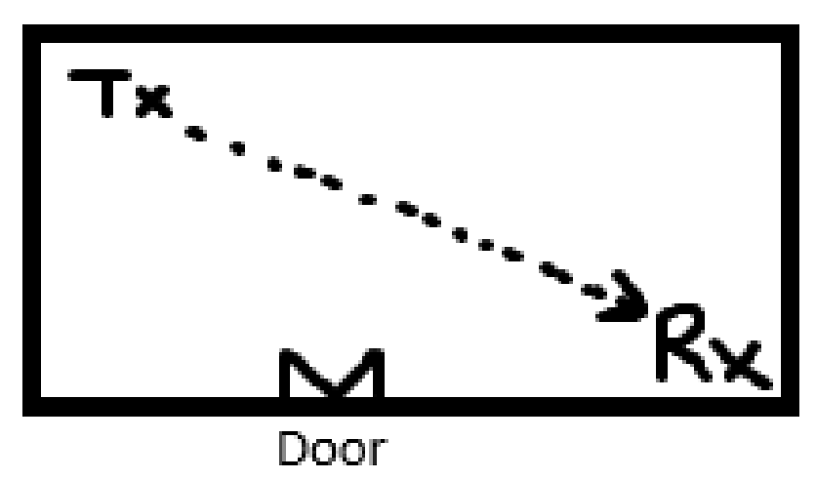
Figure 1: Illustration of the experiment setup

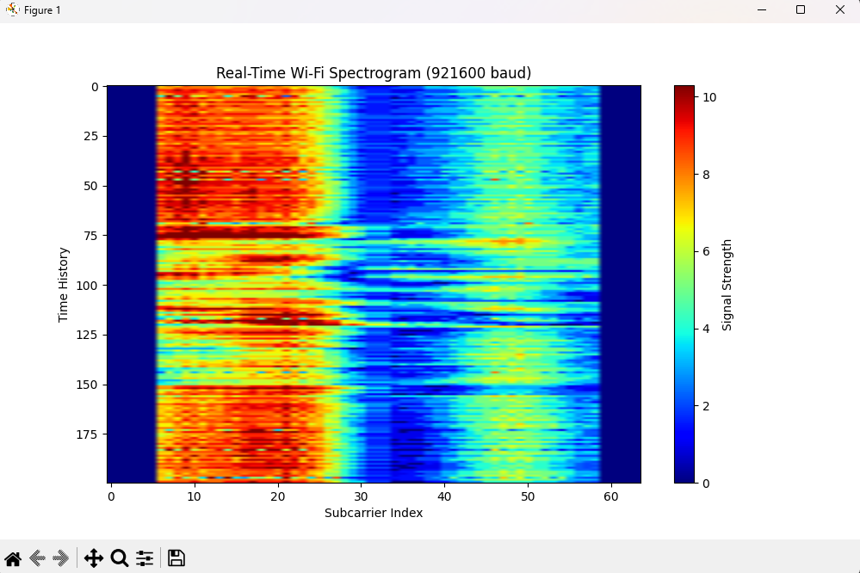
Figure 2: Walking back and forth in between the tripwire setup

Walking Through Esps Tripwire setup:
This heatmap captures dynamic motion. It shows "ripples," horizontal tearing, and intensity fluctuations.
- In this plot: The edges of the blue zone jagged, fuzzy, and wavy as you go down the Time axis (Y-axis).
- Significance: This ripple is caused by the Doppler Shift and the rapid changing of multipath reflections. As the person moves, they are constantly changing the path length of the radio waves, causing the constructive/destructive interference points to shift frequencies millisecond by millisecond.
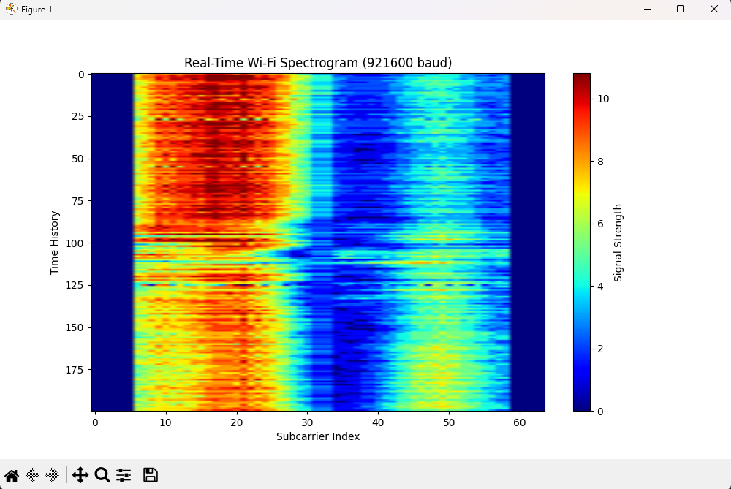
Figure 3: Running back and forth in between the tripwire setup

Running Through Esps Tripwire setup:
This heatmap captures the "Running" scenario. While the "Walking" heatmap showed gentle waves and ripples, this plot shows sharp, rapid "stuttering."
- Looking at the red block on the left (Subcarriers 6–25). In the walking plot, this area had smooth, wavy pulses. In this running plot, it is chopped up by frequent, sharp horizontal lines of lower intensity.
- Significance: This is the visual signature of speed. As you run, you pass through the constructive and destructive interference zones much faster.
- The channel state is changing so rapidly that the peaks and valleys of signal strength are compressed together on the Time axis (Y-axis). Cycling through "strong signal" and "weak signal" states.
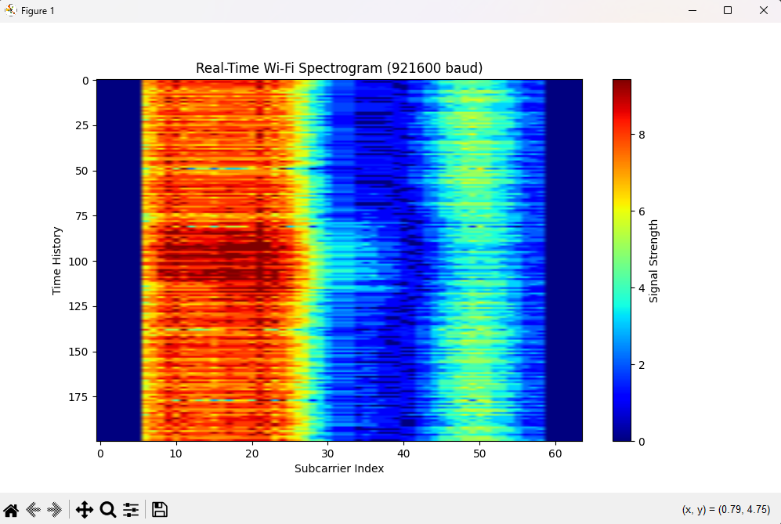
Figure 5: Individual standing still and then scratching face

Micro Detection:
This heatmap is an example of Micro Motion Detection.
While "Walking" and "Running" are large-scale events that disrupt the entire room's signal, "Scratching your face" is a localized, subtle movement. The fact that the ESP32 picked this up demonstrates the high sensitivity of the setup.

1. The "Quiet" Zones (Sitting Still)
- Location Time 0–75 and Time 125–175: The top and bottom thirds of the graph. The vertical lines are straight and consistent.
- Significance: This shows that the person was sitting completely still. The channel state was stable because nothing in the environment was moving. The red, blue, and yellow bands continue in straight lines without deviation.

2. The "Event" (The Scratch)
- Location: Time ~80 to ~115 (The middle "bulge")
      - Intensity Shift: The dark red block on the left (Subcarriers 6–25) suddenly becomes darker and slightly wider. The "Wobble": Look at the border between the red and blue zones. It doesn't "shred" like running or "wave" like walking. Instead, it gently bulges outward and then returns.
4.2 Experiment 2:
We have one Transmitter (Tx) and two Receivers. We walked in front of them, blocking the path to one while leaving the other relatively clear.

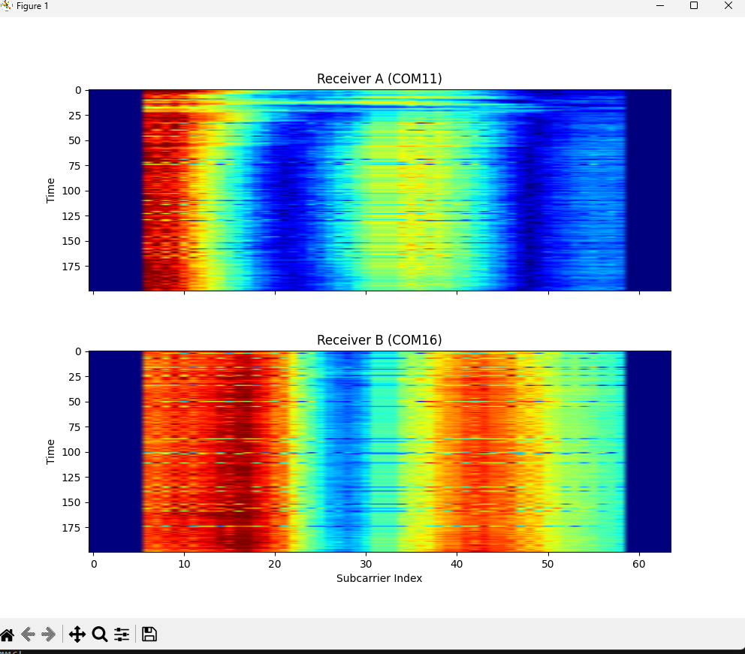
Figure 6. Triangulation Formation Standing in front of COM11

Standing in Front of COM11 (Triangulation Setup)
- Receiver A:
  - Notice the pattern of the peaks and valleys. There are strong signal blocks (red) on the far left and the center-right.
  - While you might expect Receiver A to be "dark blue" (no signal) because of the obstruction of standing in front of it, however, Wi-Fi passes around human bodies (diffraction) and reflects off nearby walls.
  - AGC (Automatic Gain Control): The ESP32's Wi-Fi radio automatically turns up the volume if the signal gets weak. So, even though the direct line of sight is blocked, the ESP32 amplifies the reflections it can hear.
  - Receiver B:
    - This receiver is clear of any ripples or waves and shows a clean heatmap indicating no obstructions or reflections

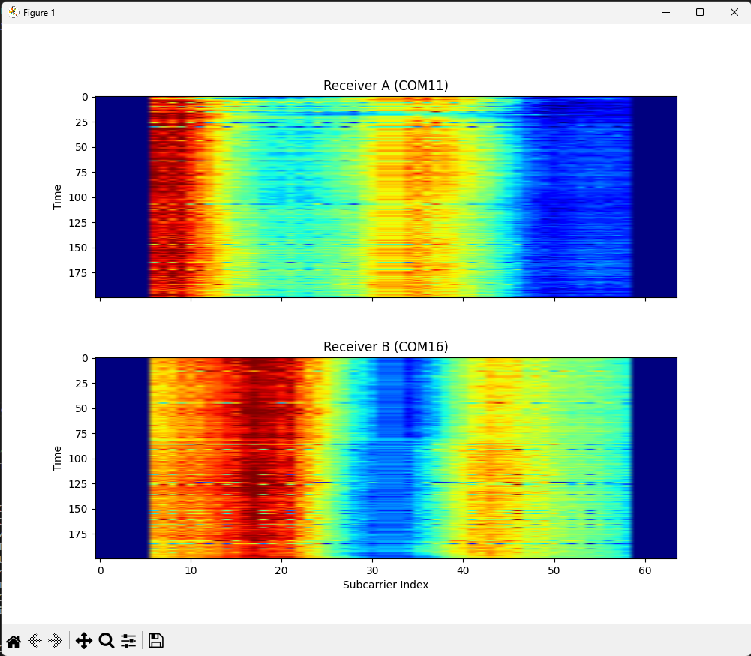
Figure 7. Triangulation Formation Standing in front of COM16
Standing in Front of COM16 (Triangulation Setup)
- You can see this is an exact copy of the waterfall heatmap above however it is inverted since we are standing in front of the other receiver.

5. Real-World Applications

Elderly Care: Privacy Preserving Fall Detection
Falls are a leading cause of injury and death among the elderly. Traditional solutions such as pendants (which are often forgotten) or cameras (which invade privacy) are imperfect.
- The CSI Solution: Wi-Fi sensing can detect falls by analyzing the speed and impact of the movement. A fall has a distinct CSI signature: a rapid, high-Doppler acceleration followed by a sudden, prolonged static period.

Security: The "Invisible" Burglar Alarm
Wi-Fi sensing acts as a volumetric sensor. Unlike a Passive Infrared sensor, which has a limited field of view and can be blocked by furniture, Wi-Fi waves penetrate objects and fill the room.
- Application: A home security system can use existing mesh Wi-Fi points to detect intruders. It can cover "blind spots" that cameras miss.
- Classification: Advanced CSI processing could distinguish between a human intruder and a pet (cat/dog) based on the "mass" of the signal displacement (magnitude of variance).²⁰

Vital Signs Monitoring: Breathing and Heart Rate
Micro Movements
- The Physics: When a person sits still, their chest moves a few millimeters while breathing. This minute displacement causes a tiny phase shift in the reflected Wi-Fi waves.
- Detection: By tracking the phase variations of specific subcarriers over time, algorithms can extract the periodic signal of breathing (10-20 BPM) and even the heartbeat (60-100 BPM). This allows for contactless sleep apnea monitoring without any sensors touching the patient.⁹

6. Conclusion
The experiments with the ESP32 have successfully demonstrated the fundamentals of this technology:
- Sensitivity: By extracting CSI, we are to gather much more important information about the environment around rather than using RSSI and its coarse "loudness" which only produces one value and provides very little information in comparison.
- Experiments: The heatmaps visually prove the existence of Frequency Selective Fading and Multipath Interference, validating the theoretical models of RF propagation.
- Localization: A 2 Receiver setup demonstrates Spatial Diversity, showing how multiple viewpoints can distinguish between blocked paths and clear ones, allowing for Localization based on zone detection logic.

Works cited
- Understanding CSI | Hands-on Wireless Sensing with Wi-Fi: A Tutorial, accessed December 15, 2025, https://tns.thss.tsinghua.edu.cn/wst/docs/pre/
- Fading - Wikipedia, accessed December 15, 2025, https://en.wikipedia.org/wiki/Fading
- Lecture Notes 10: Fading Channels Models, accessed December 15, 2025, https://www.eecs.umich.edu/courses/eecs555/lect10.pdf
- Channel State Information from Pure Communication to Sense and Track Human Motion: A Survey - PubMed Central, accessed December 15, 2025, https://pmc.ncbi.nlm.nih.gov/articles/PMC6696212/
- Poster: Comparison of Channel State Information driven and RSSI-based WiFi Distance Estimation - Carlo Alberto Boano, accessed December 15, 2025, https://www.carloalbertoboano.com/documents/salomon21csi.pdf
- A Novel Passive Indoor Localization Method by Fusion CSI Amplitude and Phase Information - PubMed Central, accessed December 15, 2025, https://pmc.ncbi.nlm.nih.gov/articles/PMC6412876/
- Wi-ESP—A tool for CSI-based Device-Free Wi-Fi Sensing (DFWS) - Oxford Academic, accessed December 15, 2025, https://academic.oup.com/jcde/article/7/5/644/5837600
- Leveraging Directional Antenna Capabilities for Fine-Grained Gesture Recognition - Xinyu Zhang, accessed December 15, 2025, https://xyzhang.ucsd.edu/papers/Melgarejo_UbiComp14_Gesture.pdf
- Wi-Fi Channel State Information, accessed December 15, 2025, https://www.emergentmind.com/topics/wi-fi-channel-state-information-csi
- Heatmap of the CSI of 800 802.11ac frames with 256 subcarriers. The... - ResearchGate, accessed December 15, 2025, https://www.researchgate.net/figure/Heatmap-of-the-CSI-of-800-80211ac-frames-with-256-subcarriers-The-first-row-shows-how_fig2_364439876
- (PDF) FallDeFi: Ubiquitous Fall Detection using Commodity Wi-Fi Devices - ResearchGate, accessed December 15, 2025, https://www.researchgate.net/publication/320453718_FallDeFi_Ubiquitous_Fall_Detection_using_Commodity_Wi-Fi_Devices
- 1 Pathloss, Shadowing and Fading - Tetcos, accessed December 15, 2025, https://www.tetcos.com/pdf/Experiments/Pathloss-Shadowing-and-Fading.pdf
- Fading in Wireless Communication - GeeksforGeeks, accessed December 15, 2025, https://www.geeksforgeeks.org/computer-networks/fading-in-wireless-communication/
- Antenna diversity - Wikipedia, accessed December 15, 2025, https://en.wikipedia.org/wiki/Antenna_diversity
- Dynamic-MUSIC: Accurate device-free indoor localization - Institutional Knowledge (InK) @ SMU, accessed December 15, 2025, https://ink.library.smu.edu.sg/cgi/viewcontent.cgi?article=4391&context=sis_research
- Indoor Localization Using 802.11 Time Differences of Arrival | Request PDF - ResearchGate, accessed December 15, 2025, https://www.researchgate.net/publication/288855895_Indoor_Localization_Using_80211_Time_Differences_of_Arrival
- Multipath Triangulation: Decimeter-level WiFi Localization and Orientation with a Single Unaided Receiver, accessed December 15, 2025, http://web.eng.ucsd.edu/~dineshb/ECE257B/papers/monoloco.pdf
- Indoor Localization with Radio Tomographic Imaging using Channel State Information - UCSC Digital Library, accessed December 15, 2025, https://dl.ucsc.cmb.ac.lk/jspui/bitstream/123456789/4796/1/2019%20CS%20146.pdf
- Commercial Wi-Fi Based Fall Detection with Environment Influence Mitigation, accessed December 15, 2025, https://www.researchgate.net/publication/335641294_Commercial_Wi-Fi_Based_Fall_Detection_with_Environment_Influence_Mitigation
- How Wi-Fi Sensing Helps Monitor Loved Ones at Home - Electronic Caregiver, accessed December 15, 2025, https://electroniccaregiver.com/how-wi-fi-sensing-helps-monitor-loved-ones-at-home/
- Cove Security: Self-Installed DIY Home Security Systems, accessed December 15, 2025, https://www.covesmart.com/
- Ge, Yao (2024) AI enabled RF sensing of Diversified Human-Centric Monitoring. PhD thesis. https://theses.gla.ac.uk/84202/ Copyri, accessed December 15, 2025, https://theses.gla.ac.uk/84202/5/2024gephd.pdf

